Swiftstylez-Ecommerce Website

**A project report**

Submitted in partial fulfilment of the requirements for the award of degree of

B.Tech(CSE)

**Submitted to**

**LOVELY PROFESSIONAL UNIVERSITY**

**PHAGWARA, PUNJAB**



**From 28/03/24 to 25/04/24**

**SUBMITTED BY**

**Name of student : Abhinav Alok Name of Supervisor : Palvi Soni**

**Registration Number : 12210433 UID of Supervisor :29451**

**List of contents**

|  |  |  |
| --- | --- | --- |
| **S no.** | **Title** | **Page** |
| **1** | Introduction |  |
| **2** | Purpose |  |
| **3** | Definitions,Acronyms and Abreviations |  |
| **4** | Table of Contents |  |
| **5** | Executive Summary |  |
| 6 | Development Process |  |
| **7** | Features |  |
| **8** | Conclusion |  |
| **9** | References |  |
| **10** | Github Link |  |
| **11** | Source Code |  |
| **12** | Pictures of Website |  |

**1. Introduction**

In the fast-paced digital era, e-commerce platforms have become essential avenues for businesses to reach out to customers worldwide. This report delves into the development process and features of Shoe Emporium, an e-commerce website dedicated to offering a wide range of shoes to online shoppers. Through the utilization of HTML, CSS, JavaScript, and Bootstrap, Shoe Emporium aims to provide a seamless and engaging shopping experience for users.

**2. Purpose**

***The shoes e-commerce website will:***

* *Provide customers with the convenience of shopping for shoes from the comfort of their homes, anytime, anywhere.*
* *Make a wide range of shoe styles, sizes, and brands easily accessible to customers, overcoming geographical limitations*
* *Offer a diverse selection of footwear options to cater to different tastes, preferences, and occasions, ensuring there's something for everyone.*

*Enable customers to compare prices, features, and reviews of various shoes effortlessly, empowering them to make informed purchasing decisions*

***The goals and objectives include:***

* *Allow shoe retailers and manufacturers to showcase and sell their unique footwear items to a wider audience. This could include a variety of shoes such as sports shoes, formal shoes, casual shoes, etc.*
* *Provide customers with access to a diverse range of footwear products, fostering appreciation for different styles, brands, and craftsmanship.*
* *Create a secure and user-friendly environment for transactions, including secure authentication and encrypted password storage. This is crucial to protect sensitive customer data.*
* *Streamline the buying process with features like search, filtering by size/brand/style, and secure checkout. This will make it easier for customers to find and purchase the shoes they want.*
* *Enhance user experience with features like user profiles, wish lists, and product reviews. This could also include features like virtual try-on or shoe size guides to help customers make informed decisions.*
* *Support the growth of small-scale shoe businesses by providing them with an online marketplace. This could also extend to supporting sustainable and ethical shoe brands.*

**3. Definitions, Acronyms, and Abbreviations**

* **HTML (HyperText Markup Language*):*** *HTML is the standard markup language for creating web pages and web applications. It defines the structure and layout of content on a web page using tags and attributes.*
* **CSS (Cascading Style Sheets**)**:** *CSS is a style sheet language used for describing the presentation of a document written in HTML. It controls the visual aspects of a web page, including colors, fonts, and layout*.
* **JavaScript (JS):** *JavaScript is a programming language that enables interactive and dynamic features on web pages. It is commonly used for client-side scripting to create dynamic content, validate forms, and enhance user experience***.**
* **Bootstrap:** *Bootstrap is a popular open-source framework for building responsive and mobile-first websites and web applications. It provides pre-designed templates, components, and plugins to streamline the development process.*

**4. Table of Contents**

* Executive Summary
* Introduction
* Development Process
* Features
* Conclusion
* References

**5. Executive Summary**

Shoe Emporium is a dynamic e-commerce platform designed to cater to the diverse needs of shoe enthusiasts. Leveraging HTML, CSS, JavaScript, and Bootstrap, the website offers an intuitive interface, secure payment gateways, and a comprehensive product catalog. The development process involved meticulous planning, coding, and testing to ensure optimal functionality and user experience. With its array of features and user-friendly design, Shoe Emporium is poised to establish itself as a premier destination for online shoe shopping.

**6 .Development Process**

The development of Shoe Emporium involved several key stages, including planning, design, implementation, and testing.

* **Planning:** The project commenced with thorough research and planning to define the website's objectives, target audience, and technical requirements. This phase also involved creating wireframes and mockups to visualize the website layout and features.
* **Design**: With the planning phase complete, the design process began, focusing on creating a visually appealing and user-friendly interface. HTML and CSS were utilized to structure the website layout, while Bootstrap facilitated responsive design for optimal viewing across devices.
* **Implementation:** The implementation phase involved coding the website using HTML, CSS, JavaScript, and Bootstrap. This stage encompassed building the frontend interface, integrating backend functionalities such as user authentication, product management, and shopping cart functionality.
* **Testing:** Rigorous testing was conducted to identify and rectify any bugs or issues within the website. This included functionality testing, compatibility testing across browsers and devices, as well as performance testing to ensure swift loading times and smooth navigation.

**7. Features**

Shoe Emporium boasts a myriad of features designed to enhance the shopping experience for users:

* ***User Authentication:*** *Users can create accounts, log in securely, and manage their profiles, including order history and saved payment methods*.
* ***Product Catalog:*** *The website offers a diverse range of shoes, categorized by type, brand, size, and price, allowing users to easily find their desired products*.
* ***Search Functionality:*** *A robust search feature enables users to quickly locate specific shoes or browse through relevant categories.*
* ***Shopping Cart:*** *Users can add items to their shopping cart, review their selections, and proceed to secure checkout for seamless purchase transactions.*
* ***Secure Payment Gateway:*** *Shoe Emporium integrates trusted payment gateways to ensure secure and hassle-free transactions, instilling confidence in users.*
* ***Responsive Design:*** *The website is optimized for various devices, including desktops, laptops, tablets, and smartphones, ensuring a consistent and enjoyable browsing experience.*

**8. Conclusion**

In conclusion, Shoe Emporium represents a culmination of meticulous planning, creative design, and robust implementation. Through the strategic utilization of HTML, CSS, JavaScript, and Bootstrap, the website offers a feature-rich platform for online shoe shopping. With its user-friendly interface, extensive product catalog, and secure payment gateway, Shoe Emporium is poised to cater to the needs of shoe enthusiasts worldwide.

**9. References**

Bootstrap Documentation - <https://getbootstrap.com/docs/5.0/getting-started/introduction/>

MDN Web Docs - HTML, CSS, JavaScript - <https://developer.mozilla.org/en-US/>

W3Schools - Online Web Tutorials - <https://www.w3schools.com/>

**10. Github Link:**

<https://github.com/mrabhi198/WebD_Project>

**11. Source code :**

* **script.html**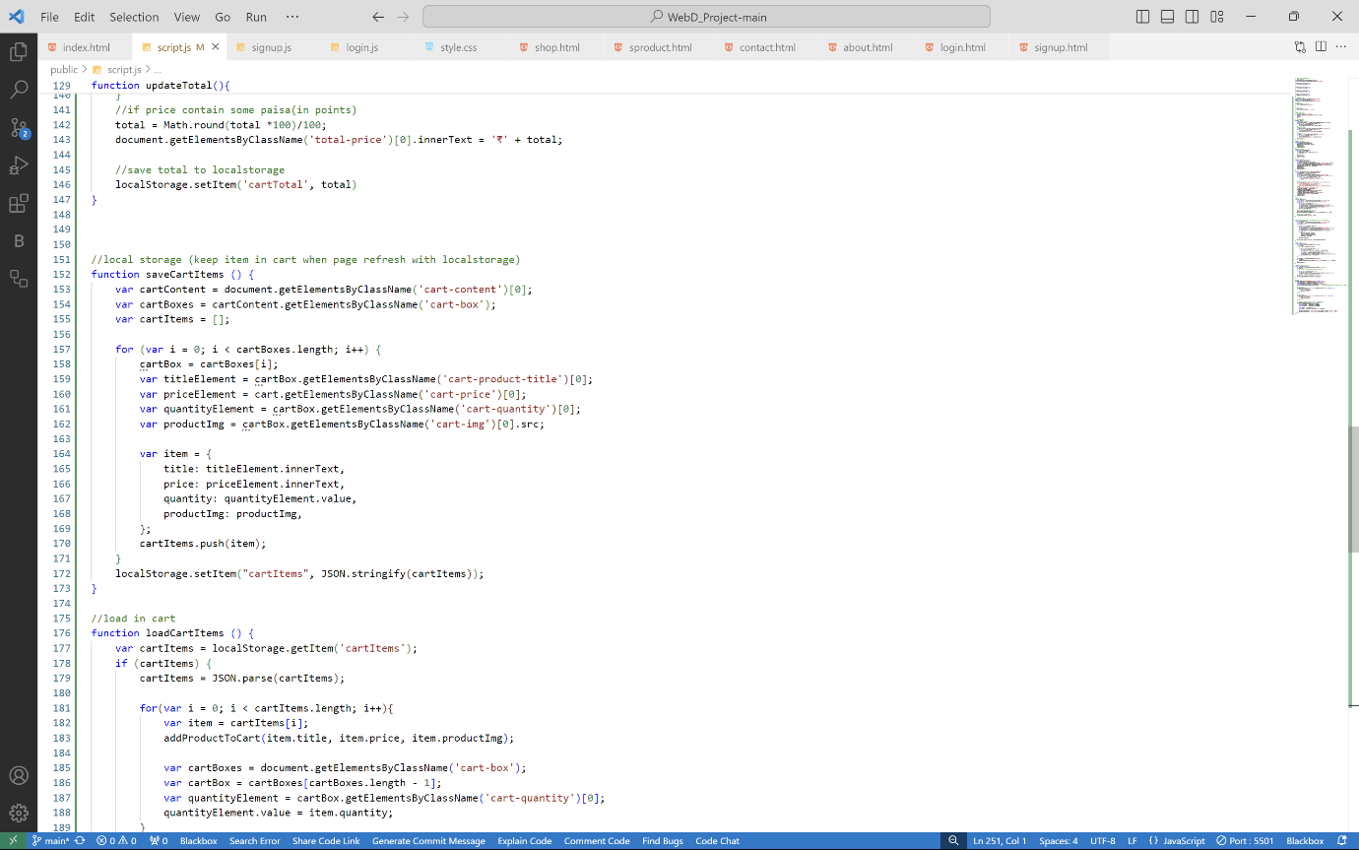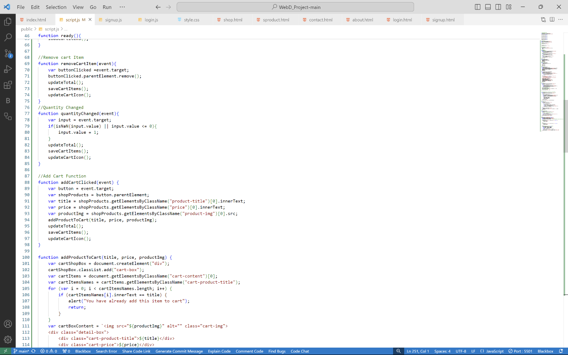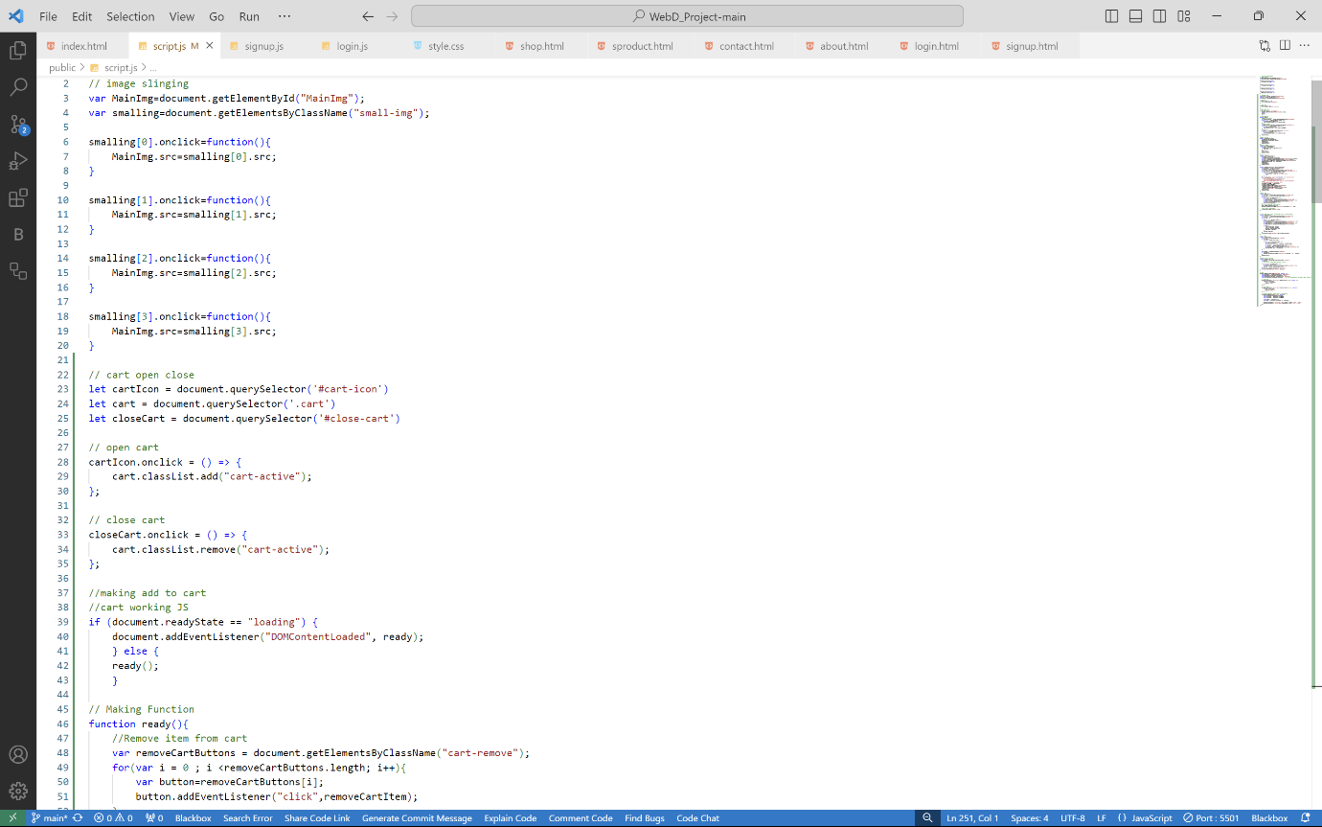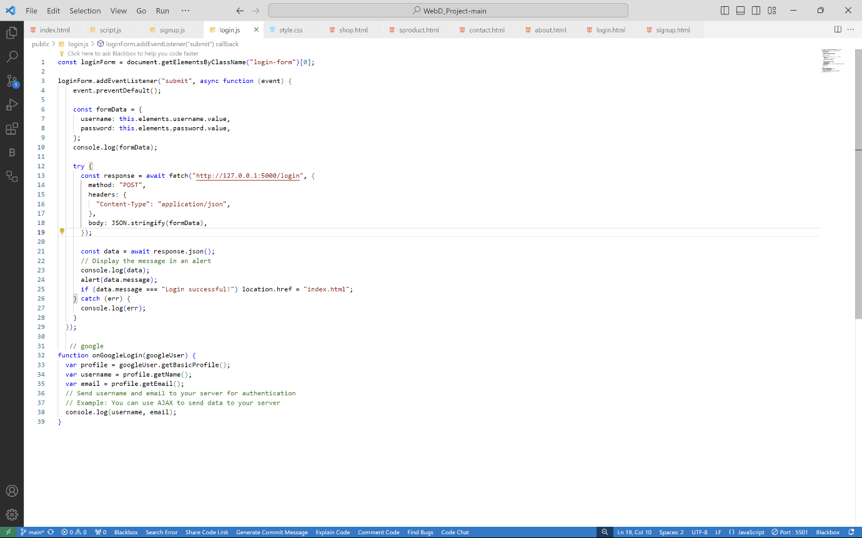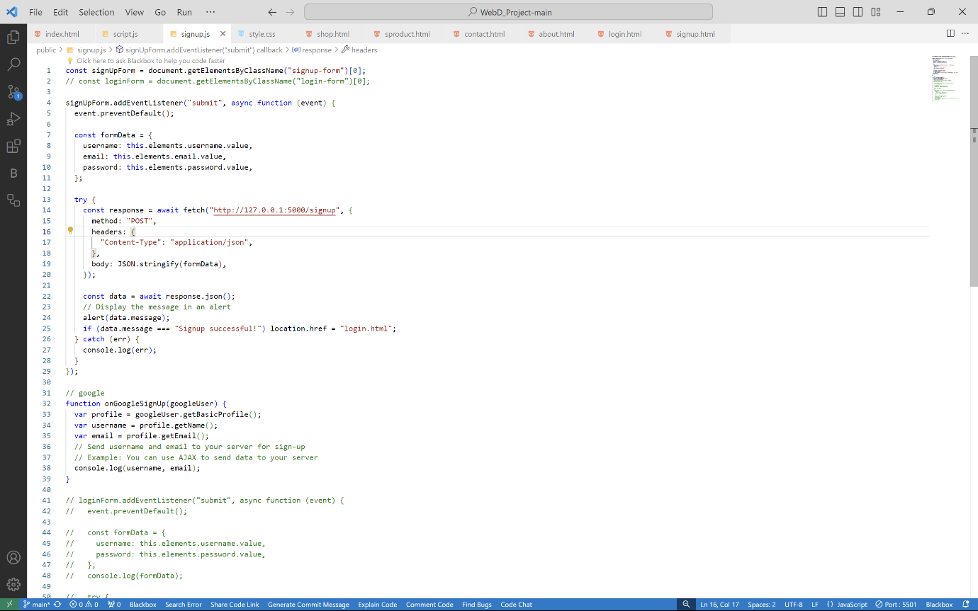
* **style.css**

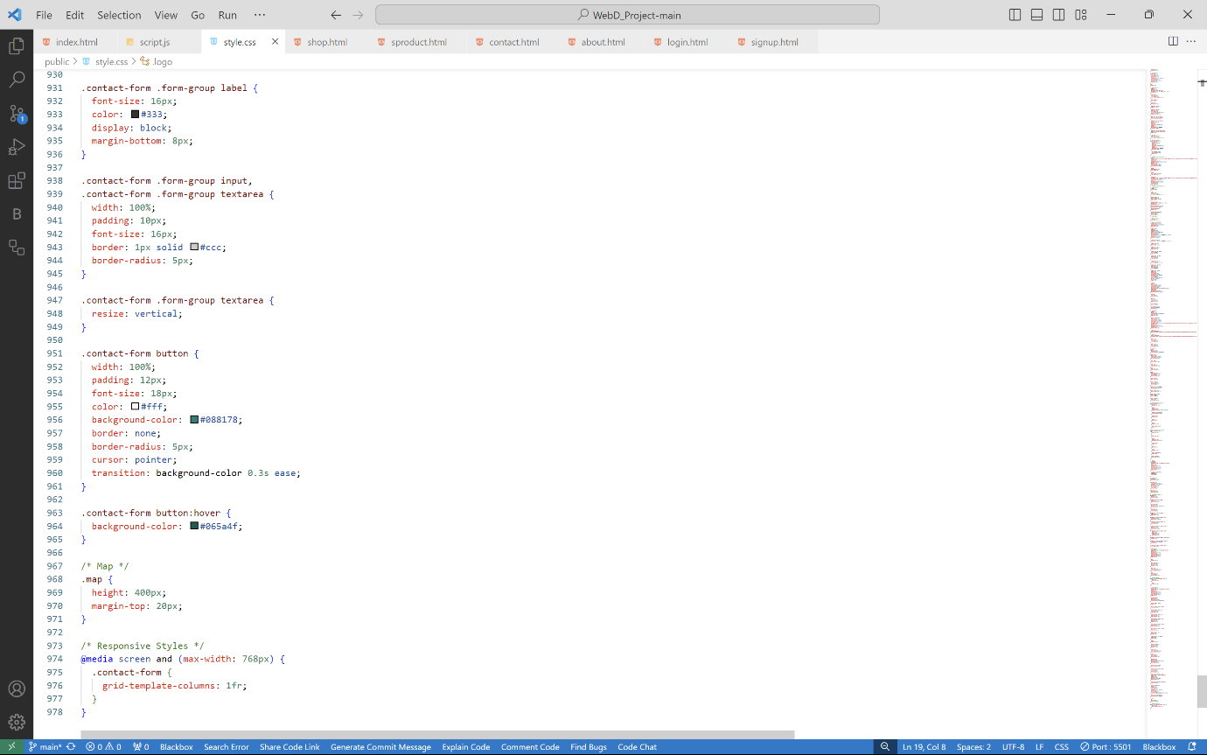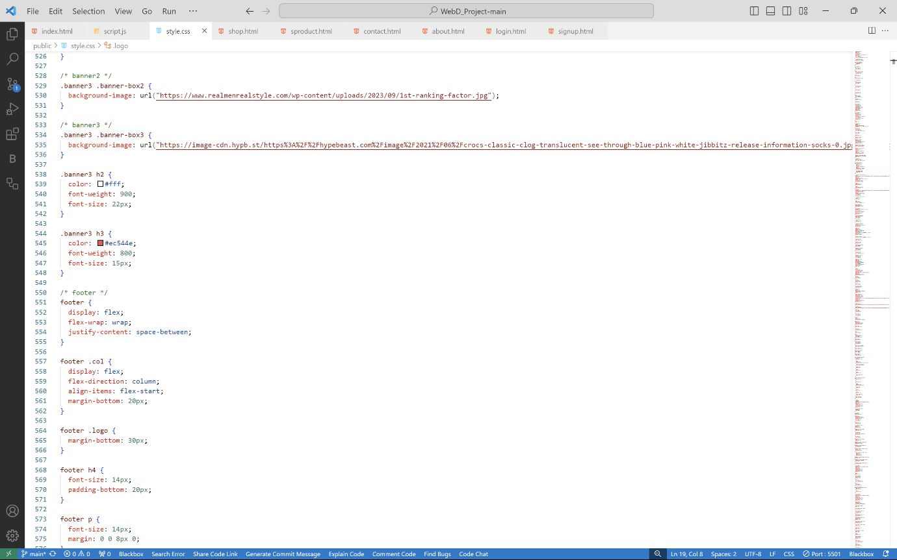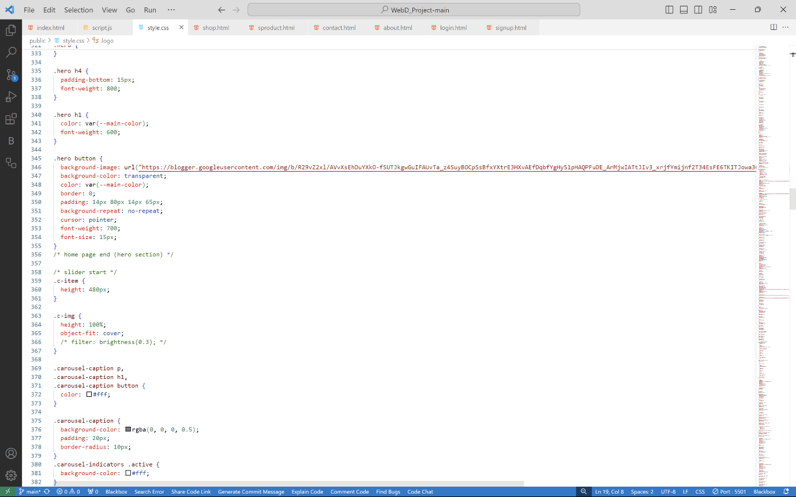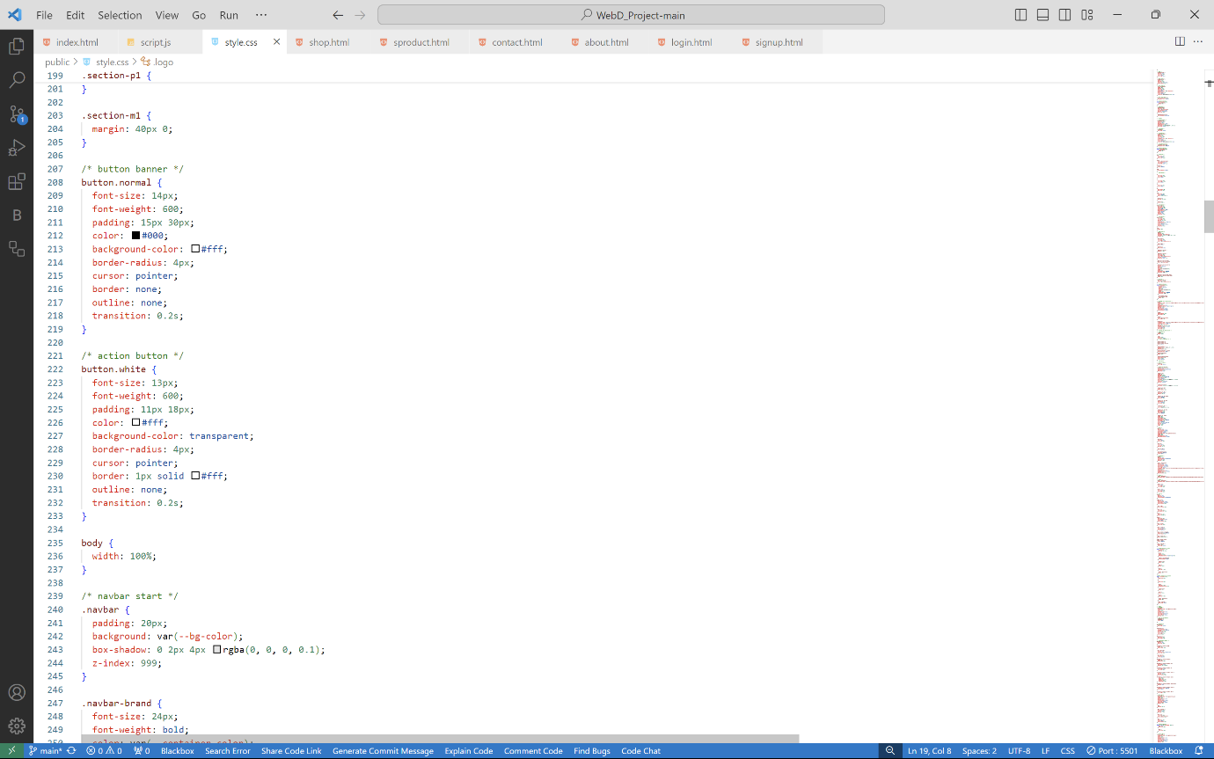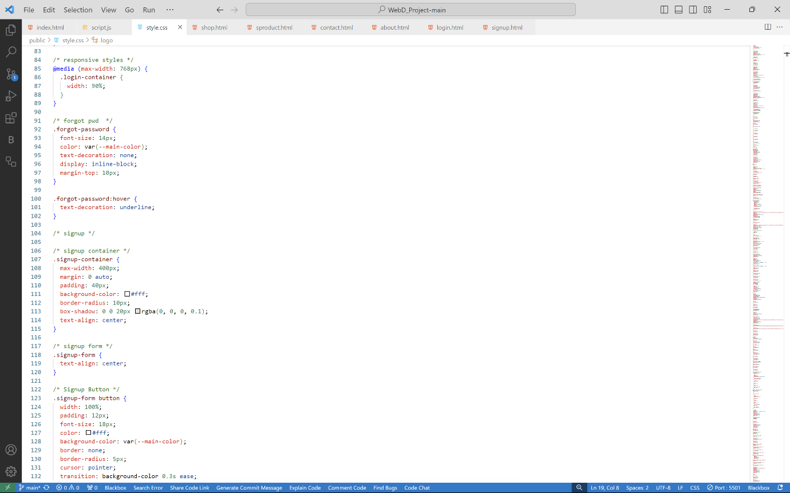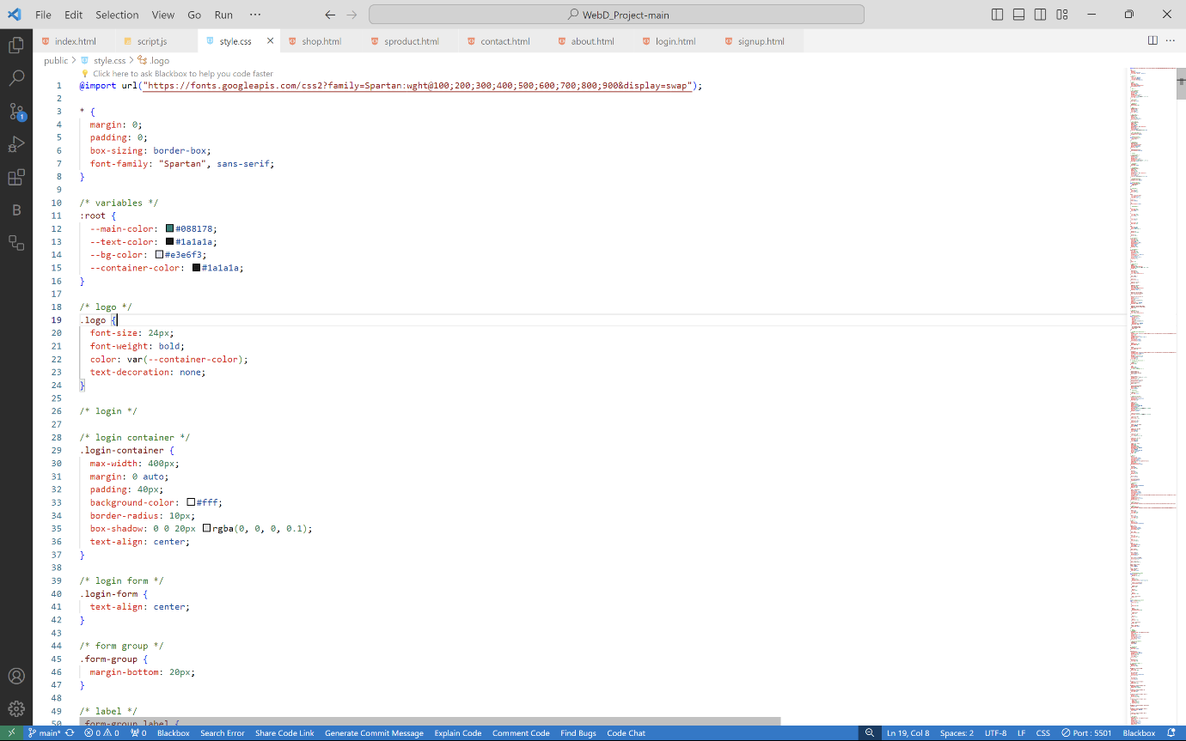

* **index.html**

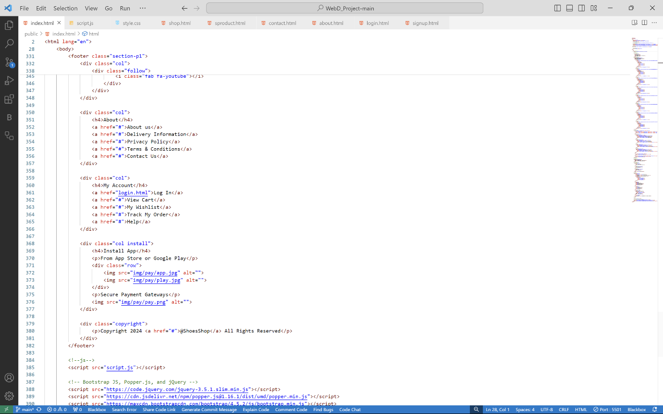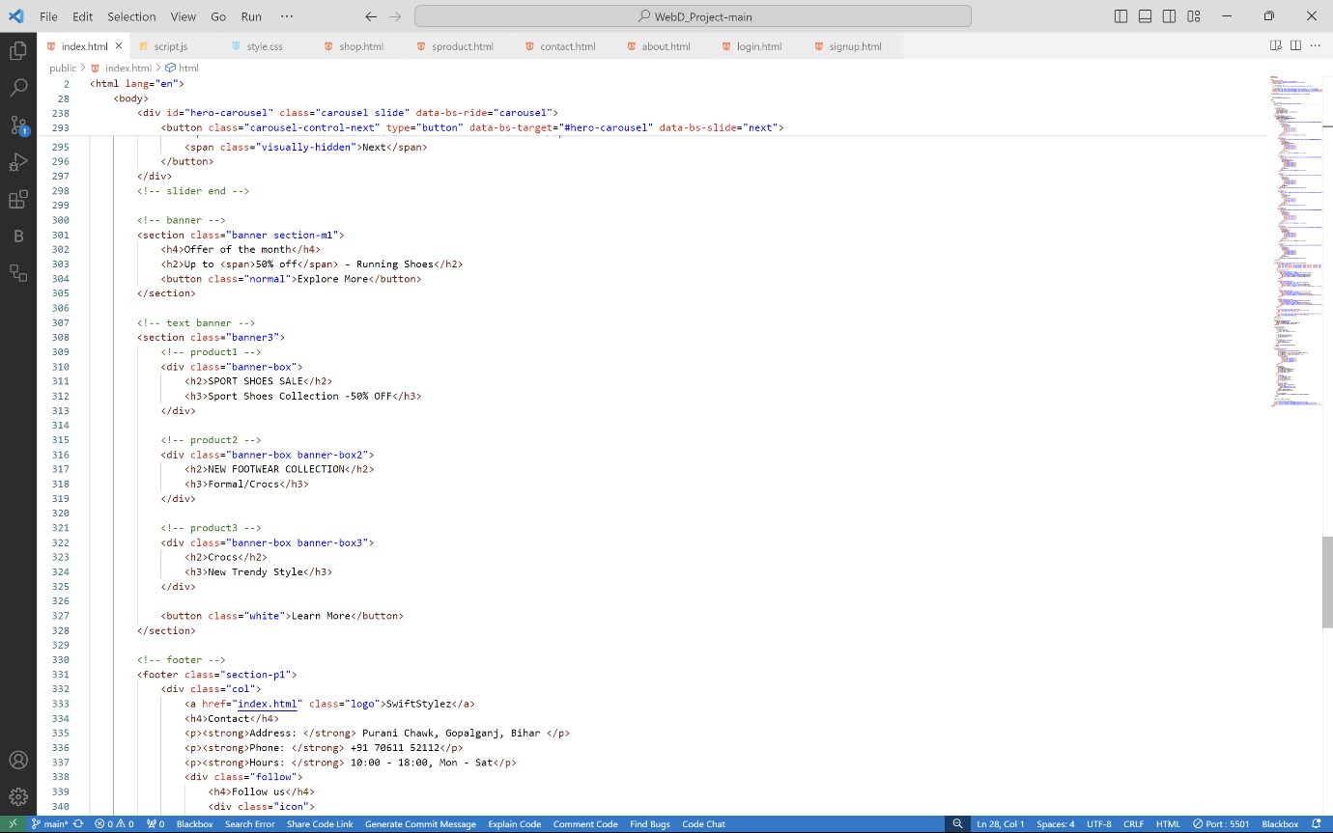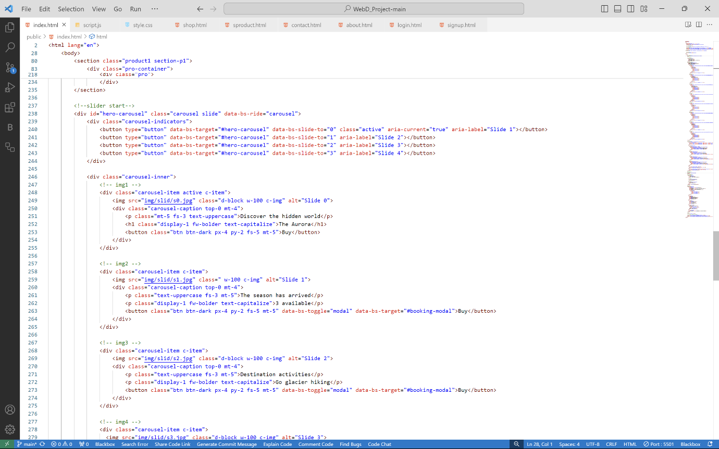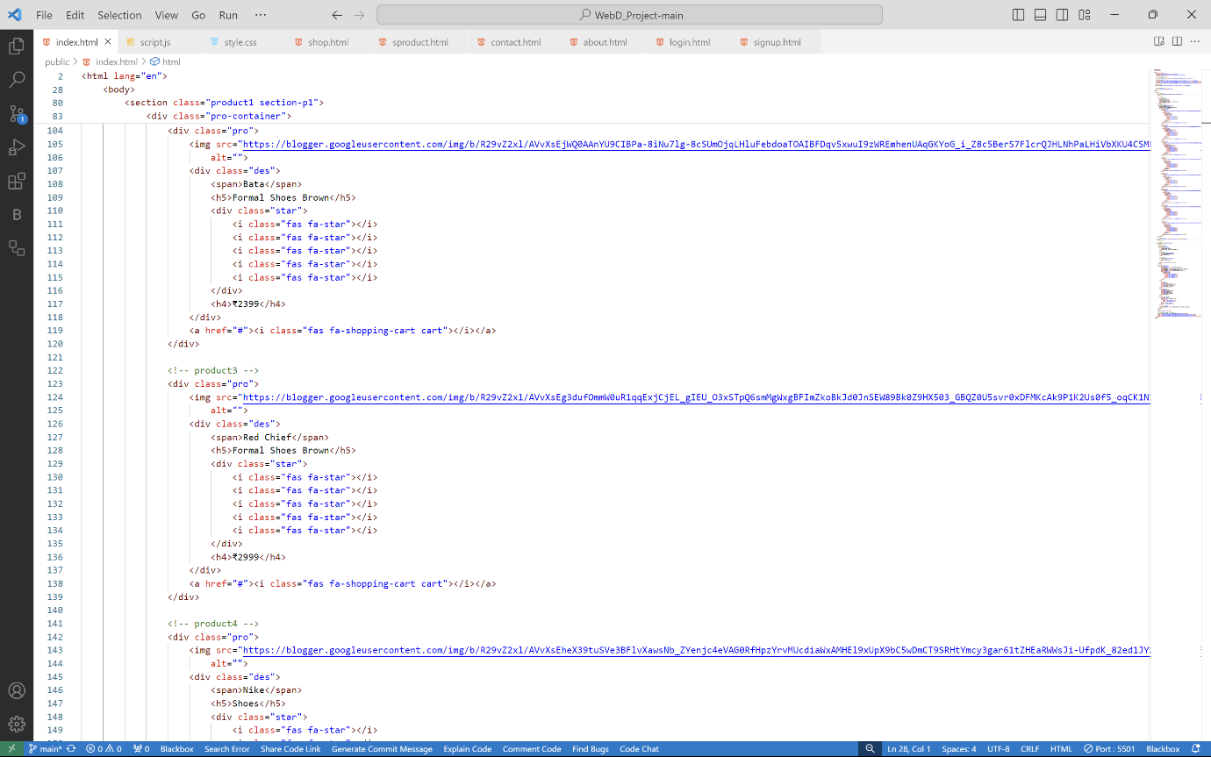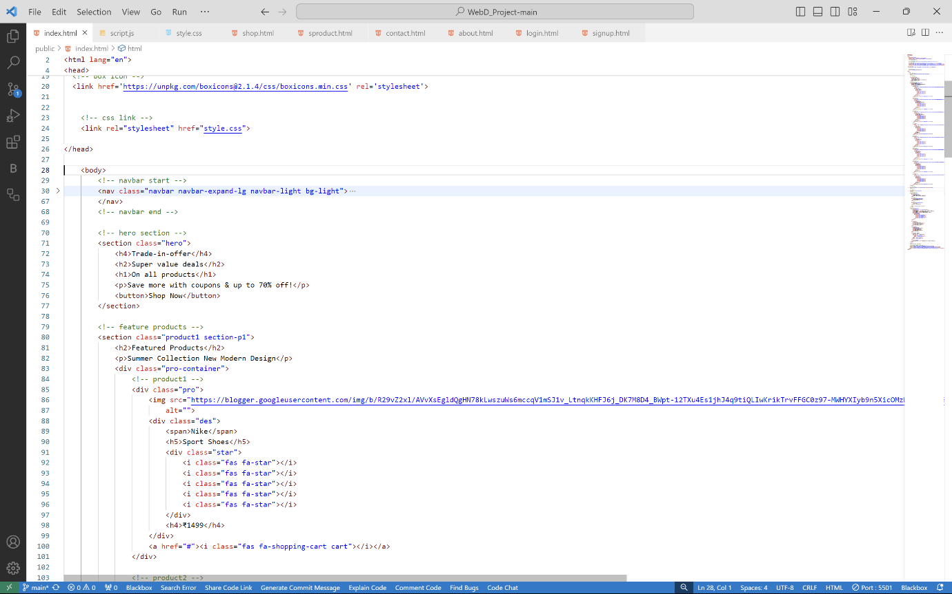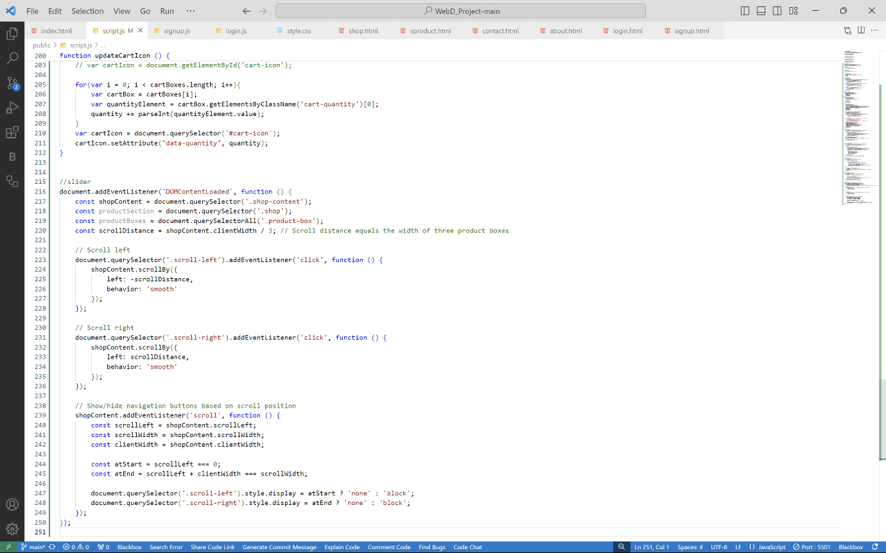

**12. Pictures of website:**

